WORK AGREEMENT

For Office Interior Fit-Out Work
Between
MHERTZ PRIVATE LIMITED
( Contractor )
And
SAARTHEE TECHNOLOGIES PRIVATE LIMITED
( Client )
Project: 18th Floor, Magnum Global Park, Sector-58, Gurugram, Haryana

16TH SEPTEMBER, 2026
SAARTHEE TECHNOLOGIES PRIVATE LIMITED
18TH FLOOR, MAGNUM GLOBAL PARK, SECTOR-58, GURUGRAM, HARYANA
SCOPE OF WORK & EXCLUSION LIST

Thank you for giving us the opportunity.
Please find enclosed our proposed List of Inclusions / Scope of Works, along with the corresponding Approved Make List and List of Exclusions for your reference.
The document has been prepared to provide a clear understanding of the proposed project scope, specifications, and responsibilities. We look forward to working together and delivering the project successfully as per the agreed requirements, quality standards, and timelines.

CARPET AREA | 2,716 sq.ft.
SCOPE OF WORK | To define the services included in the project and clearly record the stated exclusions.

1. SERVICES IN SCOPE
PART A : CIVIL & INTERIOR
- Civil and Interiors
- Glass Partitions & Doors
- Paint work
- Joinery works as/ design
- Modular Grid & gypsum Ceiling
- Carpet
- Signage, Frosting, Graphics & Logo
- Blinds
PART B : MEP SERVICES
- Electrical
- Light Fixtures
- HVAC
- Fire Alarm System
- Fire Fighting System
- Public Address System
PART C : SYSTEM FURNITURE & CHAIRS
- Modular Furniture (Work Station, Meeting Rooms etc.)
- Chairs
- Loose Furniture (incl. Breakout & Cafeteria)

 | DETAILED REVISEDFIANL BOQ FOR INTERIOR WORK - 12.09.2026
SNO | DESCRIPTION | QTY | UNIT | RATE | AMOUNT
A. CIVIL, PLUMBING & FLOORING :
1 | P/F Mix Commercial vitrified tile base for carpet flooring including PCC upto 100mm (1:4:8) | 1663 | sqft | 95 | 157,985
2 | P/F Mix Commercial vitrified tile up to 175 raised base for LVF/Hybrid wooden flooring | 285 | sqft | 185 | 52,725
3 | P/F Italian Marble Floor (Versace Beige M2) in reception, café & passages as per approved design and selection. ( Base Rate For Italian Finish Tile 470.00 per sqft. & included 20% wastage) with fixing & diamond polish. | 1280 | sqft | 1,050 | 1,344,000
4 | Café plumbing work provision CPVC & PVC complete with all accessories. | 1 | L/S | 28,000 | 28,000
5 | Café sink with crusher and Faucet. | 1 | L/S | 65,000 | 65,000
6 | Anti static raised floor tile for server room | 55 | sqft | 850 | 46,750
 | SUB-TOTAL (A) |  |  |  | 1,694,460
B. PARTITIONING, DOORS AND WOODWORK :
1 | Linear & Curved partitions in Gypsum made with 50x50mm GI channels frame with single layer of gypsum board for more sustainability filled with glass wool insulation complete. | 1760 | sqft | 160 | 281,600
2 | Server room fire rated Matel door as per design & colour complete with fire rated door frame and hardware. | 1 | nos | 45,000 | 45,000
3 | Wooden Laminated Pelmets building façade side. | 70 | rft | 650 | 45,500
4 | Column wall panelling and plater as per design in laminate/wallpaper finish. | 1 | L/S | 115,000 | 115,000
5 | Main entrance surround in designer laminate/veneer/PU finish | 40 | rft | 850 | 34,000
 | SUB-TOTAL (B) |  |  |  | 521,100
C. POP & PAINTWORK :
1 | One coat POP plaster on brickwork & Columns | 1650 | sqft | 45 | 74,250
2 | Plastic premium paint on gypsum partition, walls & ceiling | 10500 | sqft | 35 | 367,500
 | SUB-TOTAL (C) |  |  |  | 441,750
D. ELECTRICALS :
1 | Electric raceways, conduits, cables, gang boxes, sockets, switches & DB's | 3128 | sqft | 180 | 563,040
2 | DB Main Cables & temporary Connection | 1 | L/S | 35000 | 35,000
3 | Light Fittings as per approved designs and manufacturer specifications (Only linear hanging & COBs downlighters) | 3128 | sqft | 175 | 547,400
4 | chandeliers extra as per selection | 1 | nos
 | SUB-TOTAL (D) |  |  |  | 1,145,440
E. SYSTEM INTEGRATION :
1 | Voice & Data Raceways & Conduits as per plan and approved brand | 3128 | Sqft | 20 | 62,560
2 | Data, Voice, Printer, Access & wifi points including wiring (Cat 6 DLINK), IO and both end termination (active components & user end patch cords not included) Only for wi-fi, TV & printers (will be shared separately based on requirement sheet sent by Mr. Sunil.) | 0 | Nos. | 0 | -
 | SUB-TOTAL (E) |  |  |  | 62,560
F. SUSPENDED CEILING & DESIGNER FLOATERS :
1 | Suspended gypsum ceiling with coves/cornice/mouldings as per design. Meeting room, reception, ahu (flat measurement) | 3850 | sqft | 140 | 539,000
 | SUB-TOTAL (F) |  |  |  | 539,000
G. FIRE DETECTION & FIGHTING :
1 | Analog fire detection system of approved brand | 3128 | sqft | 20 | 62,560
2 | Conduiting & cabling for fire detection system | 3128 | sqft | 15 | 46,920
3 | Sprinkler system including all piping work of approved brand | 3128 | sqft | 95 | 297,160
 | SUB-TOTAL (G) |  |  |  | 406,640
H. AC DUCTING AND RELATED WORK :
1 | AC ducting with proper insulation & grills / diffusers | 3128 | sqft | 150 | 469,200
2 | AHU & related MS pipe work complete | 3128 | sqft | 200 | 625,600
 | SUB-TOTAL (H) |  |  |  | 1,094,800
 | TOTAL |  |  |  | 5,905,750
 | GST EXTRA @ 18%
 | NOTE :
 | Any other items not included in the BOQ will be charged extra
 | Design & project management fee @ 150.00/sqft extra for PMC & production drawings and 3d renders..
 | Green Plants offer will be submitted after layout finalisation
 | Electric main panel not included in offer price if required will be at an extra cost.
 | Separate air-conditioning is not considered for UPS & server room. If required separate quote to be submitted.

 | DETAILED REVISED BOQ PHASE 2 FOR INTERIOR WORK - 12.09.2026
SNO | DESCRIPTION | QTY | UNIT | RATE | AMOUNT
A. CIVIL, PLUMBING & FLOORING :
1 | Café counter wall subway/designer tiles (base rate 120.00/sqft.) | 20 | sqft | 250 | 5,000
2 | Wooden/LV Flooring on raised play zone, (Including beading/reducer etc.) | 285 | sqft | 350 | 99,750
3 | P/F of Nylon carpet in conference, workstation area & meeting room (sampling within the range) | 1773 | sqft | 220 | 390,060
4 | Café counter nano top as per design | 20 | Rft | 1,200 | 24,000
 | SUB-TOTAL (A) |  |  |  | 518,810
B. PARTITIONING, DOORS AND WOODWORK :
1 | Imported slim aluminium PVD profile glazed partitions with 8mm toughen glass complete as per design. | 590 | sqft | 750 | 442,500
2 | 12mm toughen frameless glass door complete with door spring/handle/patch fitting complete as per design. | 10 | nos | 28,000 | 280,000
3 | Reception L shaped back feature/logo wall using wooden Boxing with veneer plaster coating with wodden shelves with profile light and ready made fluted panel in natural oak finish with stone toped extended platform as shown in 3D renders. | 220 | sqft | 1,650 | 363,000
4 | 12mm HDDMR wall panelling base with nitch for profile light for conference room laminium tile and accoustic panel fixing. | 250 | sqft | 450 | 112,500
5 | 12mm HDDMR wall panelling base for meeting rooms accoustic panel fixing. (TV SIDE WALL) | 200 | sqft | 280 | 56,000
6 | Conference room TV Unit with Niches storage panelling with profile lights complete as per 3d design. | 1 | nos | 185,000 | 185,000
7 | Liminium 5mm Tiles for TV opposite wall conference room. | 96 | nos | 1,250 | 120,000
8 | Designer acoustic wall panelling in conference, meeting rooms as per 3D design. | 450 | sqft | 550 | 247,500
9 | Café service counter in laminate finish as per design. | 20 | rft | 7,500 | 150,000
10 | Town hall TV wall unit using fluted panel, laminated wooden panelling with profile and storage. | 260 | sqft | 1,650 | 429,000
11 | Break out zone TV Unit with Niches storage panelling with profile lights complete as per 3d design. | 1 | L/S | 185,000 | 185,000
12 | Café counter wall panelling/shelves in curved shape with PU paint finish. | 126 | sqft | 1,200 | 151,200
 | SUB-TOTAL (B) |  |  |  | 2,721,700
C. FURNITURE :
1 | Modular prelam Linear work station (benching system) as per approved design and colour. Including HR cabin/Telephone booth | 49 | nos | 9,500 | 465,500
2 | Pedestal drawer unit for linear workstations | 3 | nos | 5,000 | 15,000
3 | 5 Seater meeting room table in prelam finish | 2 | nos | 24,500 | 49,000
4 | Hi workstation as per design | 1 | nos | 35,000 | 35,000
5 | Overhead storage in HR room | 30 | sqft | 1,250 | 37,500
6 | 3 seater meeting room prelam modular round meeting table as per design | 3 | nos | 22,500 | 67,500
7 | 12 seater conference table in veneer/pu finish as per design. | 1 | nos | 135,000 | 135,000
8 | Café tables 4 seater laminated with metal base. | 3 | nos | 18,500 | 55,500
9 | Low height planter storage in prelam finish. | 80 | sqft | 1,250 | 100,000
10 | Café Hi Bar Table for 3 with metal base and prelam top | 1 | nos | 17,500 | 17,500
11 | Curved Planter in laminate finish Around Feature Column | 1 | nos | 55,000 | 55,000
12 | Reception single seater easy chair as per design. | 1 | nos | 28,500 | 28,500
13 | Reception three seater easy chair as per design. | 1 | nos | 95,000 | 95,000
14 | Gaming zone L shaped curved 7 seater sofa as per design. | 1 | nos | 185,000 | 185,000
15 | Gaming zone centre table in stone/veneer finish | 1 | nos | 55,000 | 55,000
16 | Reception centre table in stone/veneer finish | 1 | nos | 85,000 | 85,000
17 | Staff workstation chairs. (sampling with in the range) | 48 | nos | 5,500 | 264,000
18 | Conference room chairs. (sampling with in the range) | 12 | nos | 12,500 | 150,000
19 | Meeting & high bar pod chairs. | 27 | nos | 7,500 | 202,500
20 | Café dining chairs (sampling with in the range) | 12 | nos | 6,500 | 78,000
 | SUB-TOTAL (C) |  |  |  | 2,175,500
D. WALLPAPER & FLUTED PANELS :
1 | Wave Printed Wall paper of any design for meeting room walls | 1140 | sqft | 250 | 285,000
2 | Wallpaper for feature column | 120 | sqft | 180 | 21,600
 | SUB-TOTAL (D) |  |  |  | 306,600
E. FILM, WRITING GLASS, DECORATIVE BLINDS :
1 | Film on glass partitions and glass doors as per approved design | 1 | L/S | 65000 | 65,000
2 | Writing Glass in SS frame/back ply in Conference & Meeting Rooms | 6 | nos | 25,000 | 150,000
3 | Roller zebra Blinds of approved shade and brand | 780 | sqft | 175 | 136,500
 | SUB-TOTAL (E) |  |  |  | 351,500
 | TOTAL |  |  |  | 6,074,110
 | GST EXTRA @ 18%
 | NOTE :
 | Any other items not included in the BOQ will be charged extra
 | Design & project management fee @ 150.00/sqft extra for PMC & production drawings and 3d renders..
 | Green Plants offer will be submitted after layout finalisation
 | Electric main panel not included in offer price if required will be at an extra cost.
 | Separate air-conditioning is not considered for UPS & server room. If required separate quote to be submitted.

SARTHEE - REVISED PROJECT EXECUTION SCHEDULE

14.09.2026 -28.10.2026 | Operational Handover: 28.10.2026

CURRENT STATUS: Gypsum ~90% | POP ~80% | PCC for Italian stone 100% done and carpet/wooden tile base started | HVAC ducts at site and work in progress | AHU at site by Sun 20 Sep | Electrical conduiting & raceway complete | Fire sprinkler work complete.

# | Activity | Days | Remarks | 14-20 Sep | 21-27 Sep | 28 Sep-04 Oct | 05-11 Oct | 12-18 Oct | 19-25 Oct | 26 Oct-01 Nov
1 | Balance Gypsum / POP / PCC | 9 | Close balance civil & flooring base | ■ | ■
2 | HVAC Ducting + AHU Installation | 15 | AHU by 20 Sep; install & connect | ■ | ■ | ■
3 | MEP Balance Works | 17 | Cabling, DB, ELV, plumbing balance | ■ | ■ | ■
4 | False Ceiling / Closure | 18 | Area-wise after MEP clearance | ■ | ■ | ■ | ■
5 | Italian Stone / Polishing | 22 | Main flooring completion |  | ■ | ■ | ■ | ■
6 | Glass / Aluminium / Doors | 16 | Partitions & doors |  | ■ | ■ | ■
7 | Wall Finishes / Acoustic / Fluted / Paint | 21 | Major finishes by 15 Oct |  | ■ | ■ | ■ | ■
8 | Fixed Joinery / Storage / TV Walls | 18 | Major joinery by 15 Oct |  |  | ■ | ■ | ■
9 | Carpet / Wooden Flooring | 13 | Complete by 15 Oct |  |  |  | ■ | ■
10 | Furniture / Workstations / Chairs | 13 | Complete by 17 Oct |  |  |  | ■ | ■
11 | All Lighting Installation | 12 | Complete by 17 Oct |  |  |  | ■ | ■
12 | AC + All MEP Commissioning | 6 | Fully operational by 17 Oct |  |  |  |  | ■
13 | LOOSE FURNITURE | 14 | By 20th oct |  |  |  |  | ■
14 | Graphics / Logos / Signage / Artwork | 8 | Small design items by 25 Oct |  |  |  |  | ■ | ■
15 | Final Touch-ups / Snags / Deep Cleaning | 10 | Occupancy-ready closure |  |  |  |  | ■ | ■ | ■
16 | OPERATIONAL HANDOVER | 1 | Client can occupy & operate |  |  |  |  |  |  | ■
17 | Residual Minor Finishes / Final Snags | 10 | Controlled post-handover works |  |  |  |  |  |  | ■

KEY TARGETS: 15 Oct - major interiors substantially complete | 17 Oct - furniture, carpet/wooden flooring, all lighting, AC commissioning & all MEP commissioning complete | 25 Oct - graphics, logos, signage, artwork & small finishes complete | 28 Oct - operational handover | 07 Nov - final close-out. Note: Parallel-working programme subject to timely approvals, material availability and adequate manpower. Post-handover activities are limited to minor non-critical finishing and final snag closure without disturbing operation

3. LIST OF EXCLUSIONS

No. | Exclusion | Description
01 | EPABX / Telephony | EPBAX machine, telephone sets, console, chrome and related equipment are not supplied as part of the scope of works.
02 | LCD TV / VC / Projector Accessories | HDMI cable for TV/VC, projector mounting assembly and screen supply/installation are excluded.
03 | UPS | UPS units, batteries and racks are excluded. UPS connections/commissioning are excluded; only UPS DB provision may be provided.
04 | Projector | Ceiling/table-mounted projector, mounting kit and related equipment are excluded. HDMI/VGA cables for TV/projector are also excluded and are to be supplied/installed by the tenant.
05 | Electronic Items & White Goods | Laptops, computers, printers/scanners, TV screens, refrigerator, water dispenser, microwave, water cooler, RO plant, geysers, vacuum cleaner, split/cassette AC, precision AC, WLD, rodent repellant, air purifiers and similar electronic/white goods are excluded.
06 | Fire Extinguishers / Gas Flooding | Portable fire extinguishers (ABC or CO2 type), gas flooding equipment / clean agent systems are excluded. The source note states that conventional fire alarm and fire sprinkler works shall be completed.
07 | Accessories / Décor | Dustbins, live plants, planters, wall paintings/artworks, loose decoration pieces, sculptures and similar accessories are excluded.
08 | Company Signage and grahpics | Company signage such as, fire exit signages, cabin names, SS embossed address plates, wall graphics is excluded
09 | CCTV & PA System | Speakers equipment and CCTV equipment, including wiring and equipment, are excluded and are to be undertaken by the tenant during fit-out works.
10 | Access Control | Biometric/non-biometric access control machines, card readers, push buttons and related equipment are excluded. Only wiring provision shall be done.
11 | Active Networking & Server Hardware | Data and voice point termination at user/server ends is excluded and shall be handled independently by the tenant's IT administrator. Server rack, battery rack, firewall, patch panels, IO, RJ45 and related active/network hardware are excluded. Only provisions with cabling in conduits and numbering are stated to be done by the architect's team.

4. Commercial Proposal
Based on the carpet area and the proposed rate, our commercial offer is summarized below. The offer shall be read in conjunction with the inclusions, make list, exclusions, approved drawings, specifications and final BOQ.

Carpet Area | 2,716 sq.ft.
Proposed Rate with design included | INR 3,300 / sq.ft.
Total Project Value | INR 89,62,800 ( GST EXTRA)
Amount in Words | Rupees Eighty Nine Lacs Sixty Two Thousand Eight Hundred Only

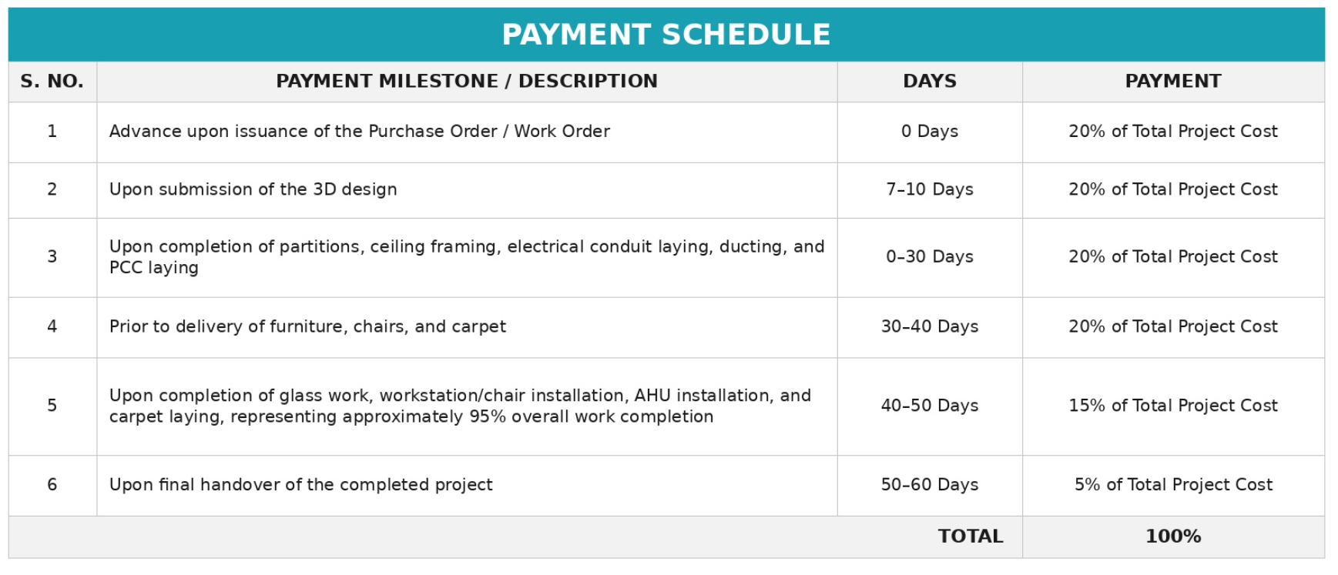
General Terms
- Project mobilization shall commence upon receipt of the Purchase / Work Order and 20% advance payment.
- The execution timeline of 75 calendar days shall be effective from the date of project mobilization.
- Any additional work or variation beyond the approved BOQ shall be carried out only after mutual approval and will be billed separately.
- The project schedule is subject to uninterrupted site access, timely approvals, and availability of required utilities.
- Timelines depend as per the client approvals and payment schedule.
5. Closing Note
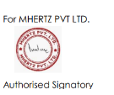
We sincerely thank you for giving us the opportunity to participate in this project. We have prepared the above scope and commercial proposal with the objective of delivering a high-quality, functional and well-coordinated workplace in line with the agreed design intent and project requirements.
We look forward to the opportunity to work together and successfully deliver the project. We shall be pleased to discuss any scope clarifications, technical requirements or commercial details required for finalization.
Commercial Note: The above project value is calculated at INR 3,300 per sq.ft. on a carpet area of 2,716 sq.ft. Taxes, payment terms, project duration, validity, and any item outside the stated scope/exclusions shall be finalized separately in the commercial offer / work order.

APPROVED PLAN

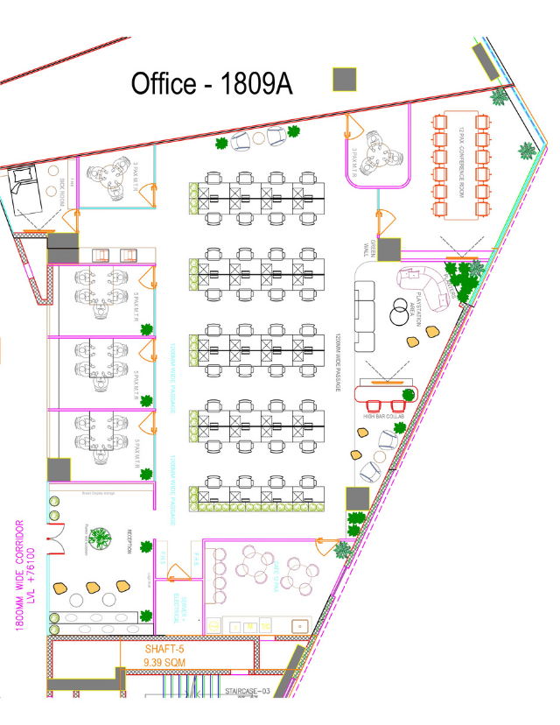

LOOK AND FEEL
